**UI Testing**

1. Home page loaded successfully.

1. The search option is working correctly.

1. Enter the product name “Nike React” and the product page is showing successfully.

1. Select **“Nike odyssey react flyknit 2”** and the product is showing successfully.

1. Selects size - S and color - Black, but the size is showing XL and the color is showing Pink instead of showing the size (S) and color (Black) in the product page.

1. Clicks “ADD TO CART” and adds 4 products and product added successfully but the color and size is showing different in the add to cart page.

1. Product “QUANTITY”, “INDIVIDUAL PRICE” and “TOTAL PRICE” are showing accurately in the shopping cart page.

**Defects Report ( UI )**

**ID** - DEF_001

**Summary** - Color and Size is showing “XL” and “Pink” after choosing size - S and color - Black.

**Steps to Reproduce** -

* Open Nike Odyssey React Flyknit 2 product page.
* Change color to Black and size to S.

**Expected Result** - The color and size should be updated.

**Actual Result** - Still shows size - XL and color - Pink.

**Severity** - High.

**Priority** - High.

**Status** - New.

**Environment** - <https://demo.evershop.io/>

DEF_001 (Color and Size is showing “XL” and “Pink” after choosing size - S and color - Black)

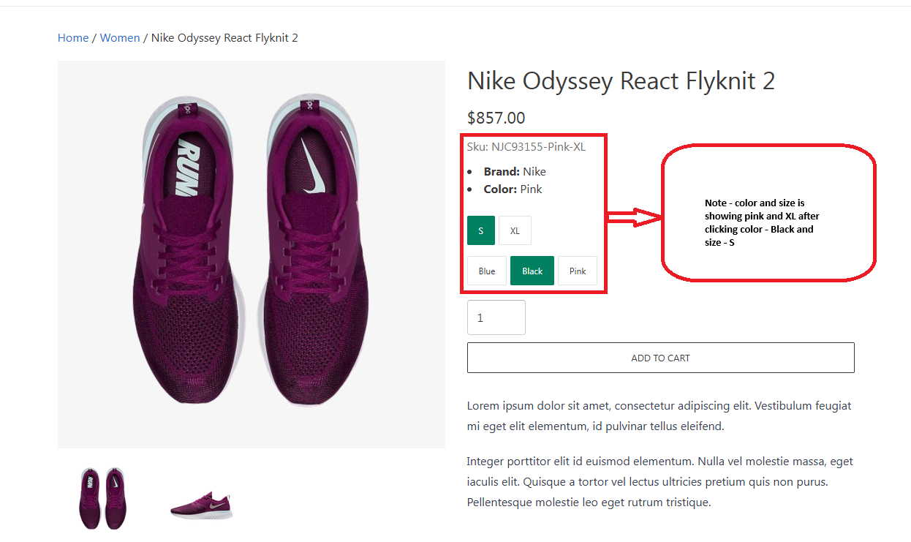

**API Testing**

1. Search product API is working correctly.

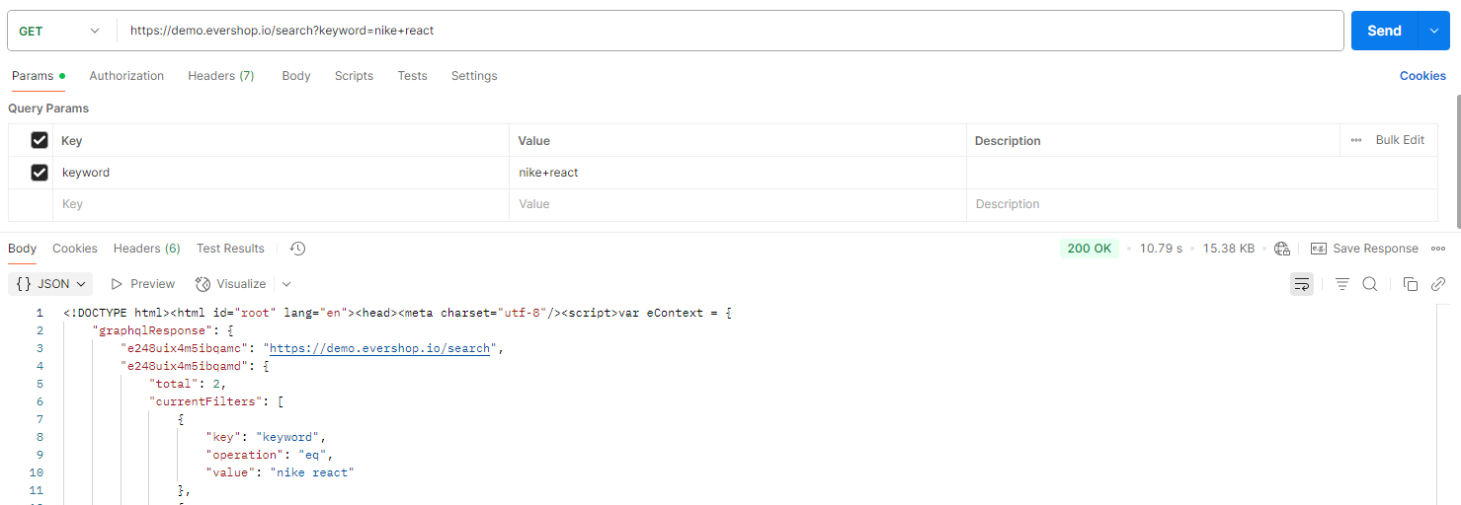

1. Select **“Nike odyssey react flyknit 2”** and the product is showing accurately and the API is working correctly.

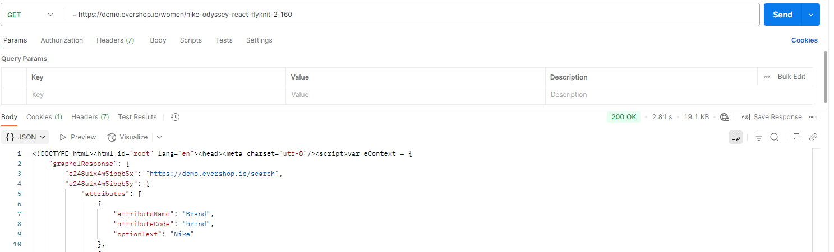

1. Input color and size value ( size = 25 , color = 14 ), API is working but instead of showing the ( color = Black and size = S ) it is showing ( color = Pink and size = XL).

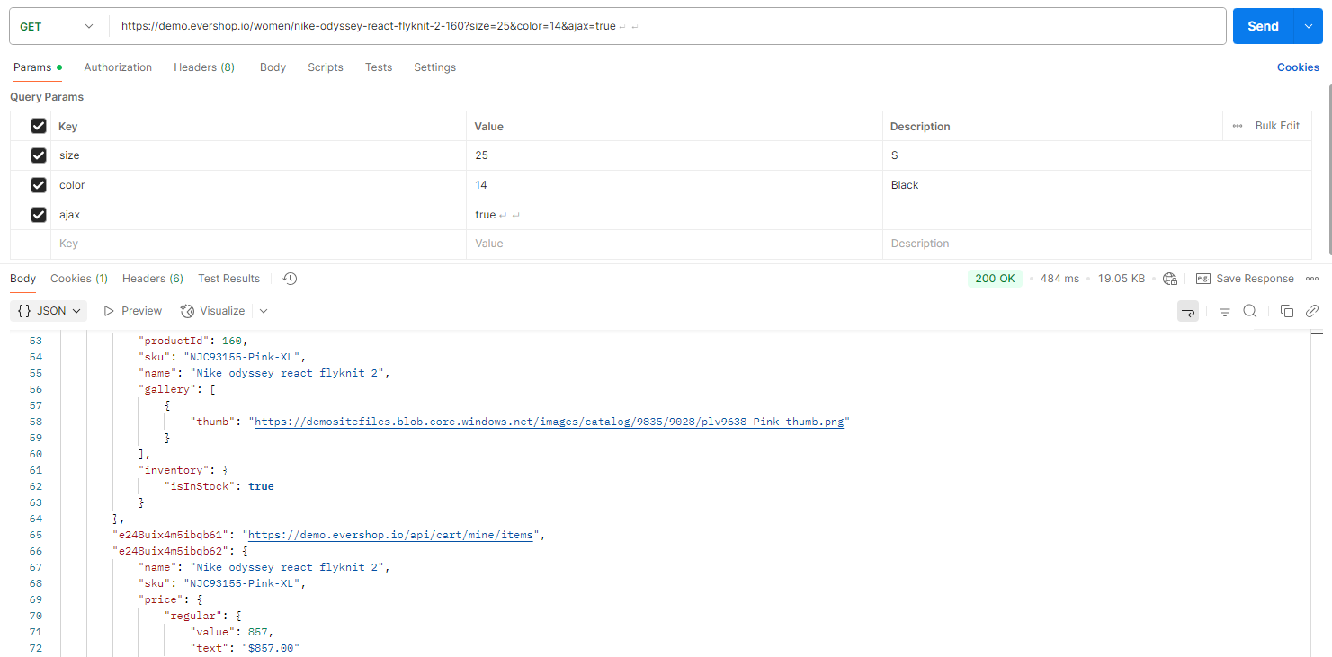

1. Add to cart API is not working for the color = black and size = S. It is giving **“500 Internal Server Error”**.

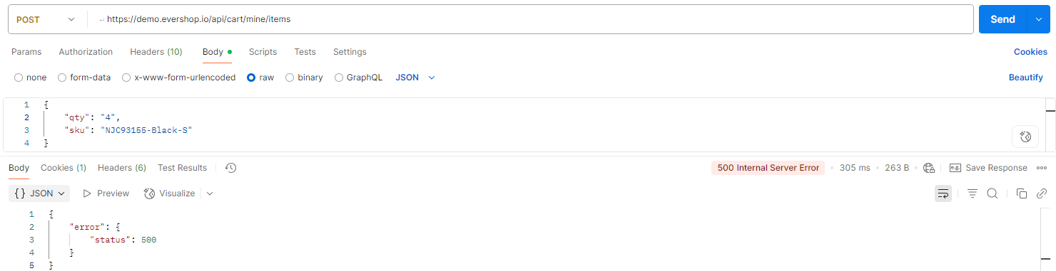

**Defects Report (API)**

**ID** - DEF_002

**Summary** - Showing different color and size after giving the right values of size and color.

**Steps to Reproduce** -



**Expected Result** - The color and size should be updated to **"NJC93155-Black-S"**

**Actual Result** - Still shows **“NJC93155-Pink-XL”**

**Severity** - High.

**Priority** - High.

**Status** - New.

**Environment -** Postman.

DEF_002 (color and size is not matching)

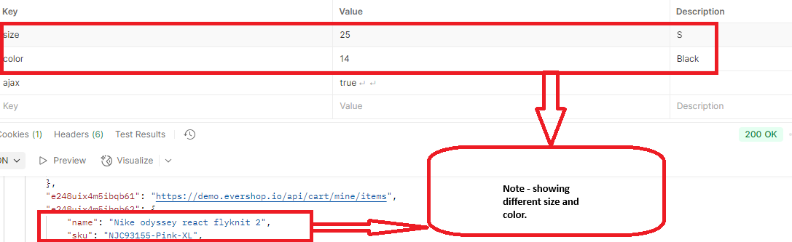

**UI Testing Report**

1. Home page working properly.

1. Search option is working properly.

1. View product is working properly.

1. Color and size is not showing properly.

1. Different color and size and is showing in the add to cart section instead of showing the expected color and size.

1. But the add to cart functionality is working properly.

1. View cart page is also working properly ( showing the right quantity , individual price and total amount ).

**API Testing Report**

1. Search product API is working correctly.

1. View product API is working but it is not returning the expected product. It is showing **"NJC93155-Pink-XL"** instead of showing **"NJC93155-Black-S"** after giving the right color and size value of the product.

1. Add to cart API is not working for **"NJC93155-Black-S"** product and unable to add it to the cart.